# 

# Executive Summary

## **The Computer of My Dreams**

# Introduction

*The proposal presents a high-performance system geared toward extreme gaming, 3D content creation, and professional video editing. With an approximate budget of $12,200 USD, the configuration leverages state-of-the-art components to maximize computing speed, redundant storage capacity, and a smooth visual experience.*

# Problem Summary

*To meet the requirements of heavy multitasking, 4K gaming, and multimedia editing, I selected AM5-compatible components with PCIe 5.0 support and DDR5-6400 memory. The shortlist of key parts includes:*

* *Motherboard: Gigabyte X670E AORUS XTREME*
* *Processor: AMD Ryzen 9 7950X3D*
* *Liquid cooling: ARCTIC Liquid Freezer III Pro A-RGB*
* *Memory: 96 GB DDR5-6400 CL32*
* *Graphics card: Asus ROG Astral OC RTX 5090 32 GB*
* *NVMe/HDD storage in RAID*
* *Thermaltake W200 case + Enermax 1350 W power supply*
* *Displays: 2× Asus ROG Swift PG32UQXR 4K 160 Hz*
* *High-precision peripherals and immersive audio*

# Analysis Findings

## *The different components are presented below, along with their price and supplier.*

## Motherboard: *Gigabyte X670E AORUS XTREME (EATX AM5)*

## *X670E chipset, AM5 socket*

## *5 M.2 PCIe 5.0 slots, PCIe 5.0 x16, DDR5 up to 6400 MHz+*

## *Price: $949.99*

## *Supplier: Amazon*

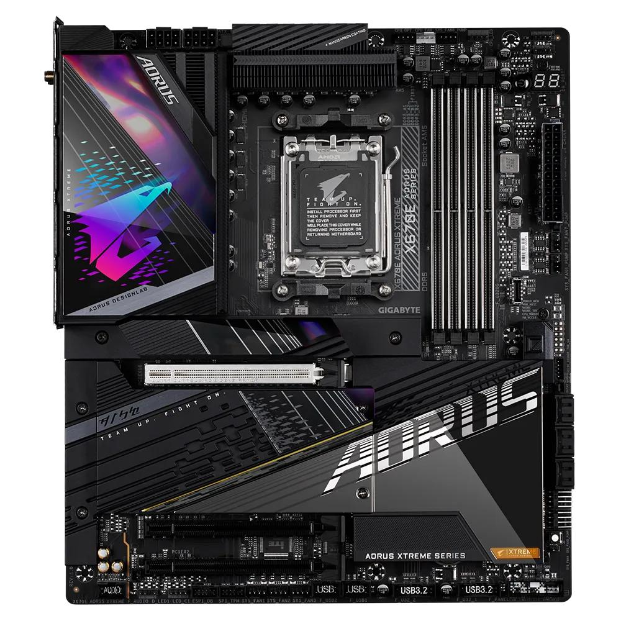

## Processor: *AMD Ryzen 9 7950X3D 4.2 GHz (16-Core / 32-Thread)*

## *128 MB L3 cache, TDP 120 W*

## *Cinebench R23 Multi ~38,000 pts*

## *Price: $769.27*

## *Supplier: MemoryC (Amazon Marketplace)*

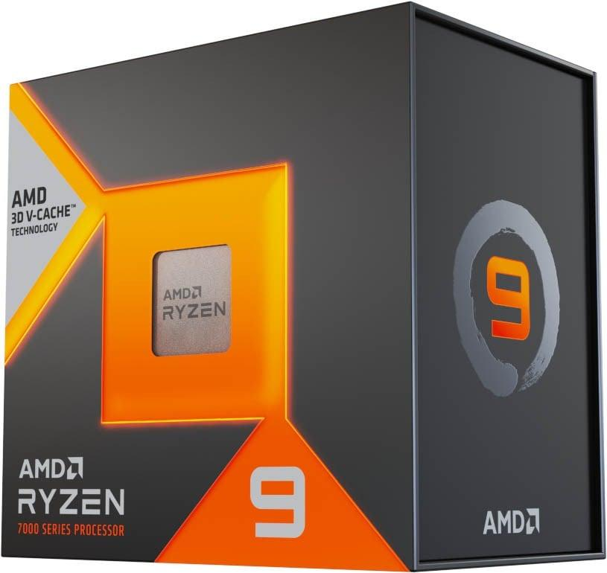

## Cooling Solution: *ARCTIC Liquid Freezer III Pro A-RGB*

## *360 mm radiator, 110 CFM fans*

## *AM5 compatible*

## *Price: $107.99*

## *Supplier: Amazon*

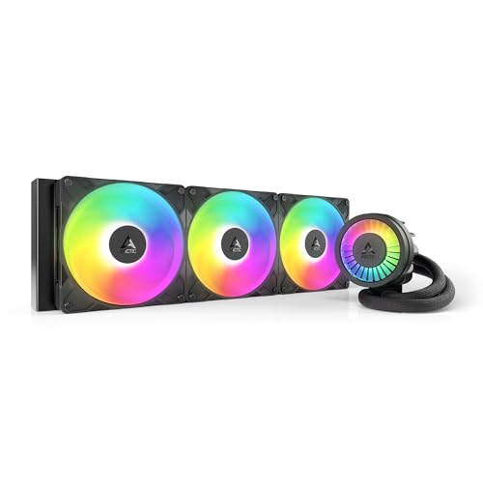

## Memory: *TEAMGROUP T-Create Expert DDR5-6400 CL32 (4×24 GB)*

## *Total 96 GB, quad-channel, 1.35 V*

## *Total price: $291.98*

## *Supplier: B&H Photo*

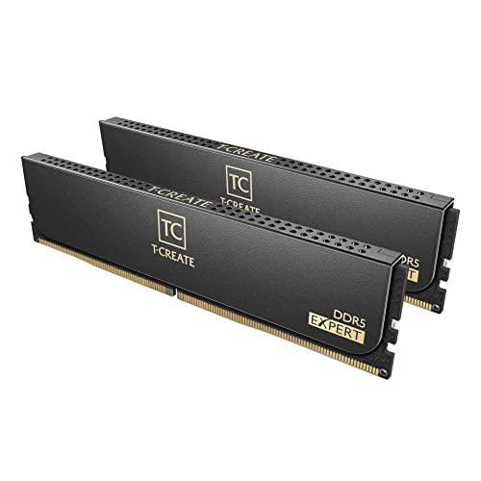

## Graphics Card: *Asus ROG Astral OC GeForce RTX 5090 32 GB*

## *PCIe 5.0, 32 GB GDDR7*

## *~125 FPS in 4K Ultra (AAA)*

## *Price: $3,359.99*

## *Supplier: Amazon.*

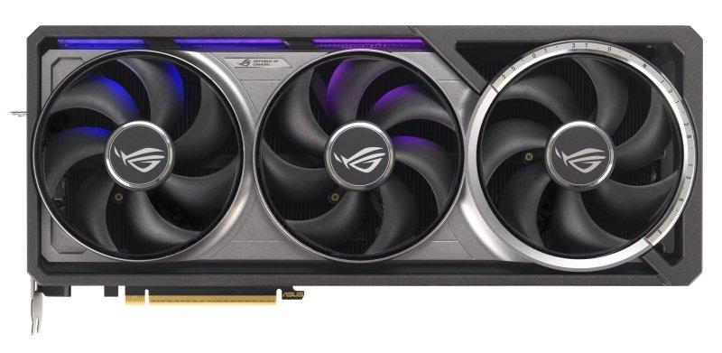

## Mass Storage:

## *4× Crucial T700 4 TB NVMe PCIe 5.0 (RAID 5): 16 TB usable, ~12 GB/s sequential*

## *Total price: $1,519.96*

## *Supplier: Amazon*

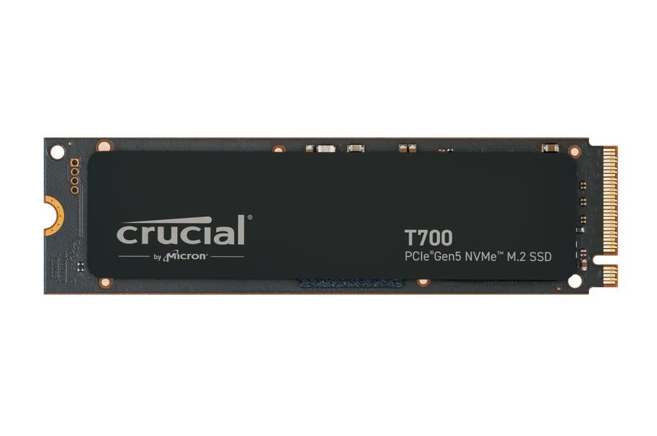

## *4× WD Red Pro 24 TB HDD (RAID 5): 54 TB usable, massive capacity*

## *Total price: $1,999.96*

## *Supplier: Western Digital Direct*

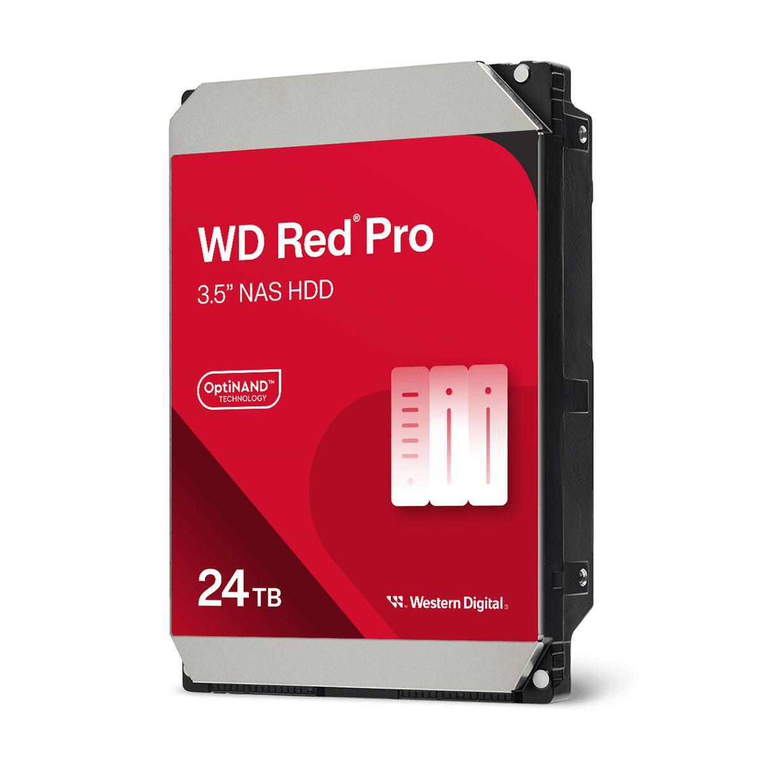

## Case/Power Supply: *Lian Li O11 Dynamic EVO XL ATX Full Tower Case + Enermax MAXREVO SLI 1350 W 80+ Gold*

## *ATX/E-ATX support, modular design with tempered glass front and extensive cable management*

## *Space for multiple radiators and HDD/SSD*

## *Case price: $243.99 – Supplier: Newegg*

## *Modular power supply: $139.99 – Supplier: Amazon*

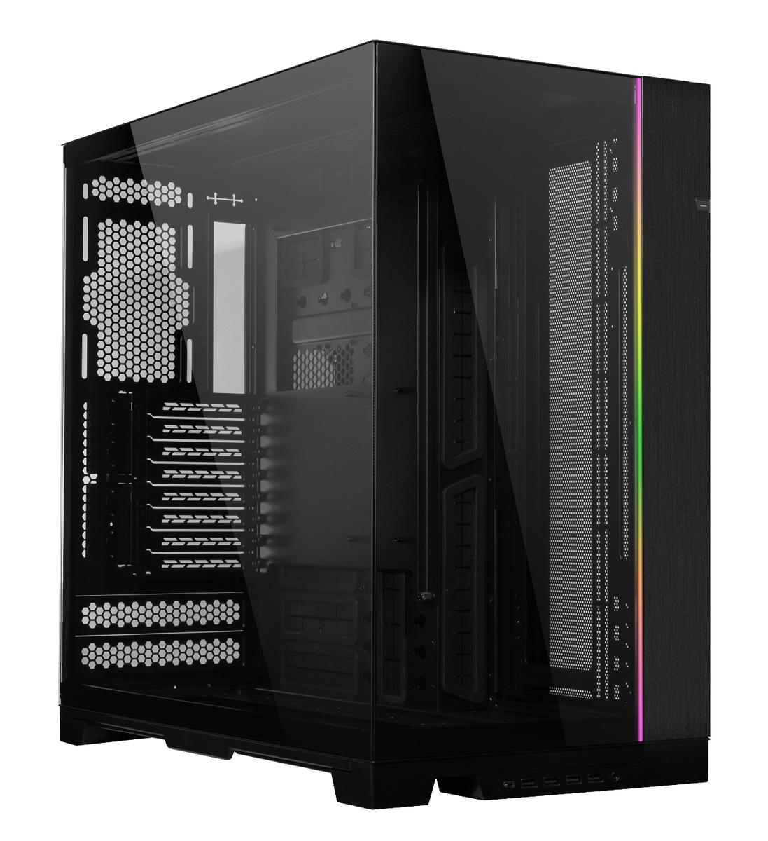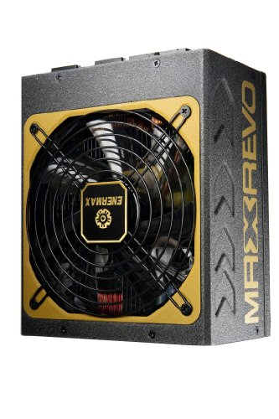

## Display: *2× Asus ROG Swift PG32UQXR 32" 4K 160 Hz*

## *IPS 1 ms GTG, G-Sync Ultimate*

## *Price per unit: $977.99 (x2 = $1,955.98)*

## *Supplier: Amazon*



## Peripherals:

## *Razer BlackWidow V4 RGB keyboard ($159.99) – Amazon*

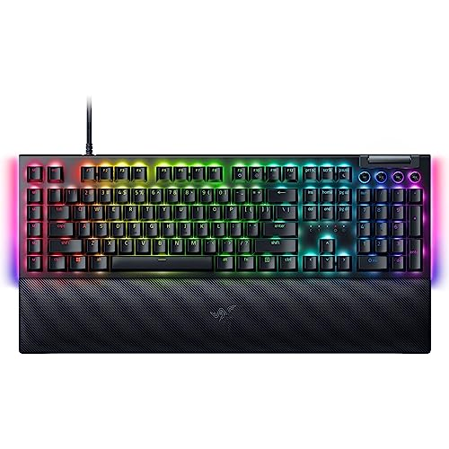

## *Logitech MX Ergo S Plus mouse ($109.99) – B&H Photo*



## *JBL Quantum One headphones ($329.95) – Amazon*



## *Razer Kiyo Pro Ultra Webcam ($299.99) – Razer Official Store*

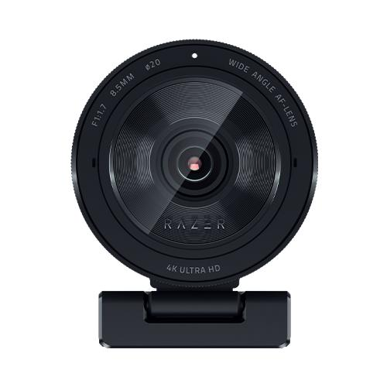

# Conclusion

*This design offers exceptional performance in multitasking, 4K gaming, and redundant storage. The projected total cost is $12,429.01, within the updated budget of $12,500 USD, with room for future upgrades.*